17.15: From the point-slope formula for a straight line (or linear regression, which, while perhaps not appropriate, may be convenient for some calculators),
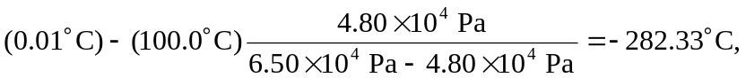

which is 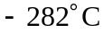 to three figures.

b) Equation (17.4) was not obeyed precisely. If it were, the pressure at the triple point would be 